To complete a Master's Degree in Engineering Management, the student must complete 30 credits:

- Four core management courses (12 credits)
  - EGRMGMT 510- Marketing
  - EGRMGMT 520- Intellectual Property, Business Law, and Entrepreneurship
  - EGRMGMT 530- Finance in High-Tech Industries
  - EGRMGMT 540- Management of High-Tech Industries

- Four technical elective courses (12 credits)

- Two semesters of Seminar & Workshop Series (0 credits)
  - EGRMGMT 501- Engineering Management Seminar

- Internship, written project summary, oral presentation (6 credits)
  - EGRMGMT 550- Engineering Management Internship
  - EGRMGMT 551- Engineering Management Internship Assessment

Two vs. Three semester options
- It is best to know which plan you choose when registering for classes so you do not end up paying more than you have to.

TWO SEMESTER SAMPLE SCHEDULE
Fall
- Two Core Courses- EGRMGMT 510 and EGRMGMT 530
- Two Technical Electives
- Seminar and Workshop- EGRMGMT 501
- Internship Courses- EGRMGMT 550 and 551 (if you have completed your internship prior to arriving to campus)

Spring
- Two Core Courses- EGRMGMT 520 and EGRMGMT 540
- Two Technical Electives
- Seminar and Workshop- EGRMGMT 501

THREE SEMESTER SAMPLE SCHEDULE
Fall (semester 1)
- Three Courses
  - Two Core Courses
    - EGRMGMT 510 and 530 are only offered in the Fall
  - One Technical Elective
- Seminar and Workshop
Spring (semester 2)
- Three courses
  - Two Core Courses
    - EGRMGMT 520 is only offered in the Spring and EGRMGMT 540 is offered in the Fall but to a limited number of students; we highly suggest you take EGRMGMT 540 in the spring
  - One Technical Elective
- Seminar and Workshop
Summer
- Internship
- If you are an international student and if internship in US, take EGRMGMT 550
Fall (semester 3, international students MUST be enrolled it at least 9 credits)
- Remaining Two Technical Electives needed to graduate
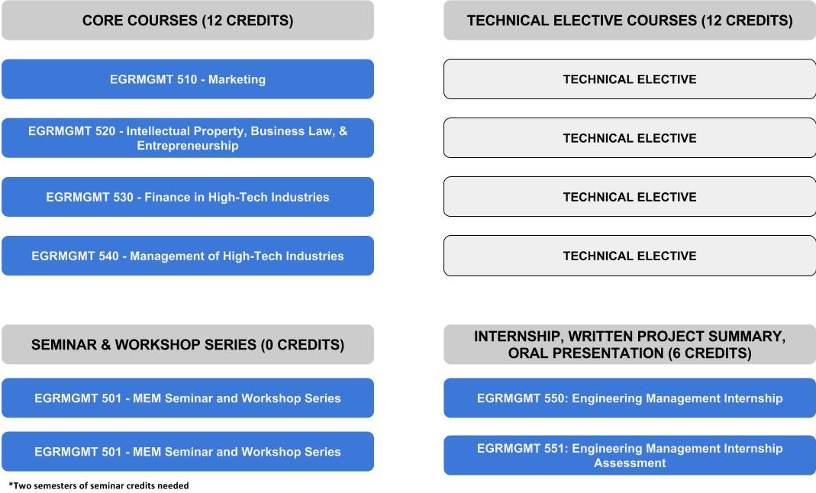
- EGRMGMT 551 (perhaps EGRMGMT 550 if you didn't take it during the summer)

